ECE Senior Design Weekly Report

**Engineer’s Name:** Leon Tran             **Date:** 03/15/17

**Team Name:** The Globetrotters **Lab Section:** 4

**Week’s Task:** Have the Rough Draft of the GUI finished

**Results:**

* HTML Based Web Interface
  + 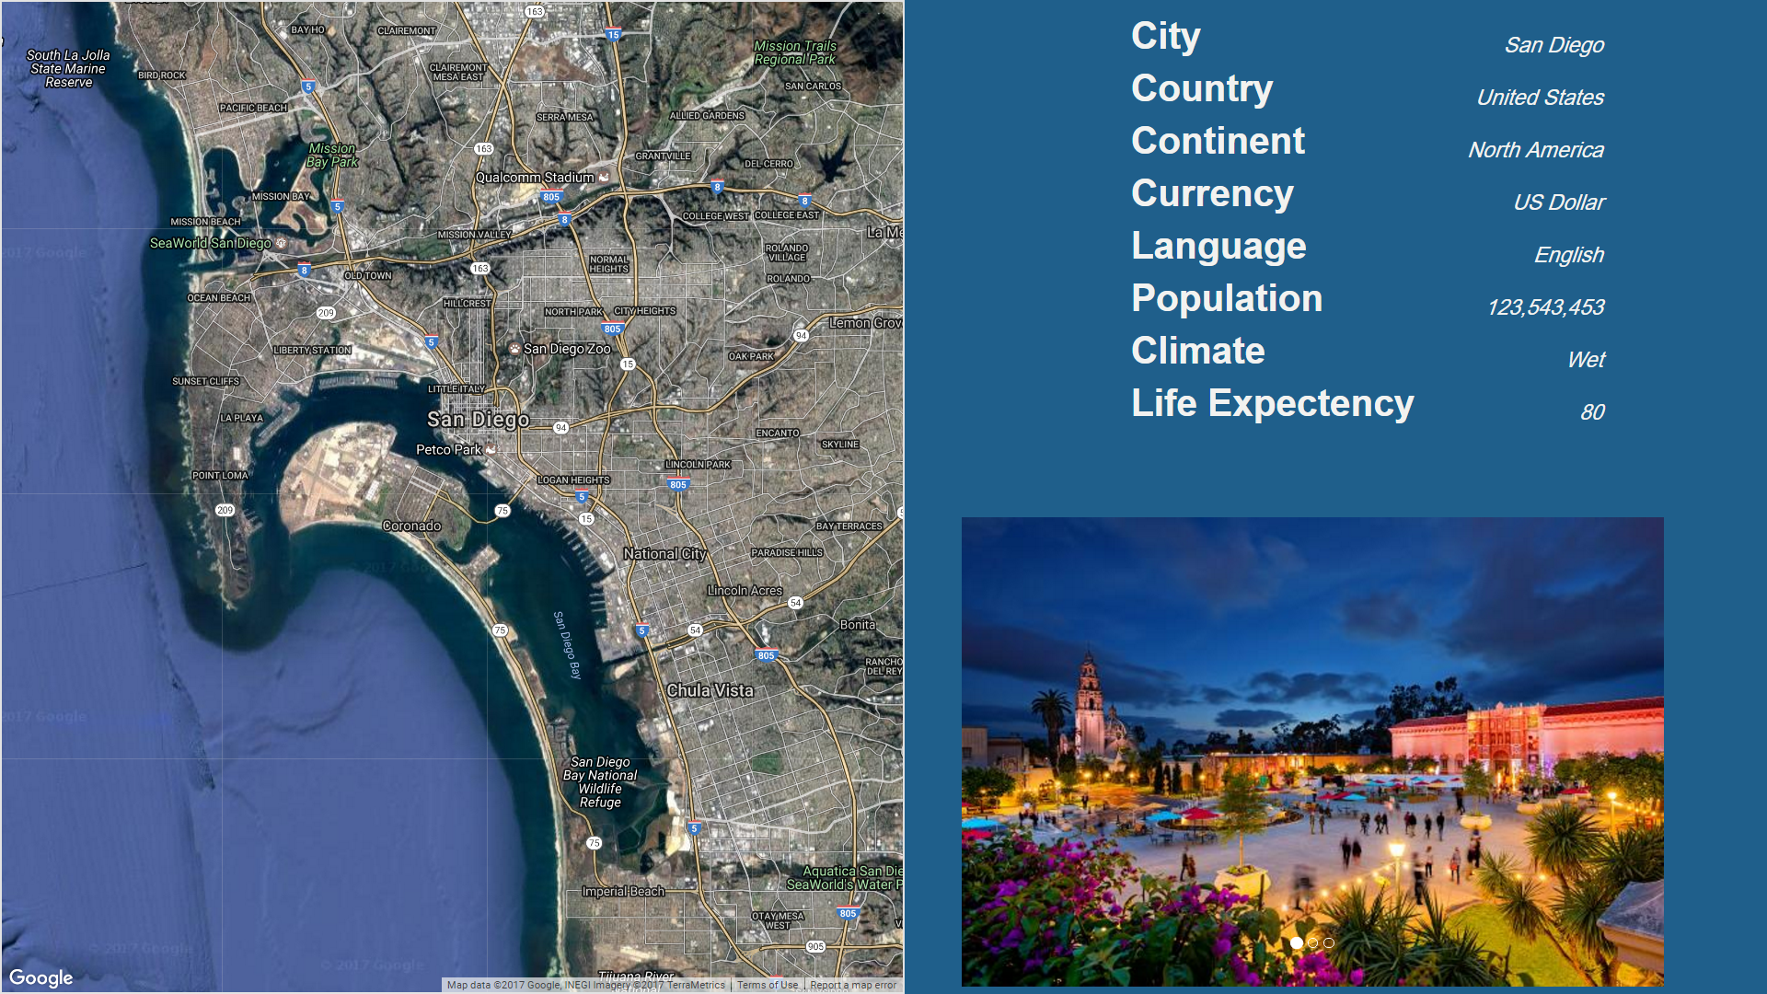
  + Updates Dynamically with a.JSON file
  + Stored on a local server on the Raspberry PI
  + Switched to showing a Google Map API instead of using QGIS, as we are only using the map to show location and not necessarily analyzing the data in that area.